# TYPOGRAPHY BASICS

1. TYPE FACE/ FAM- name of a specific collection of related fonts like roboto and future
2. Font- particular weight/font/styleor width or variance of that type face

Fonts fall in two categories (basic)

1. Serif- Serif has some peculiarities like 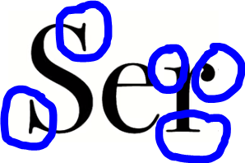
2. Sans-Serif - without peculiarities.

Weight is like adding extra pounds to ur font.

Leading=Line height

Line height=Leading -🡪 Proximity b/w each line

Character Spacing/ Tracking -> Giving more space b/w each character

Kearning- Similar to tracking but the diff is it’s about rearranging two or more specific characters.

Type.method.ac 🡪 site for manual kerning

Ligature- two or more letters are joined to form a single glyph 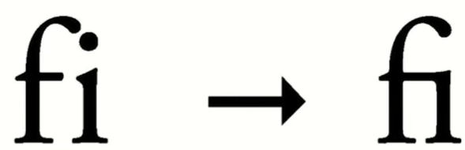

Measure - width of the text box. Should be 10-14 words per box

Rag- it is the shape it makes on the rhs

Widow- word that’s lying at the end of the paragraph by itself

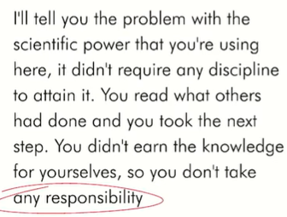

Orphan- part of a sentence that carries over and starting a paragraph right itself 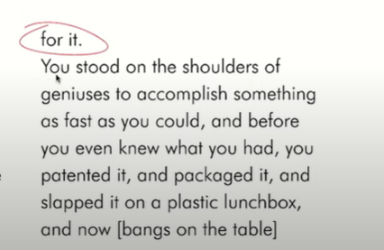

TIMELESS FONTS:

1. Garamond
2. Badoni
3. Century Expanded
4. Futura
5. Times Roman
6. Helvetica

HARD AND FAST RULES

1. Always justify left- start left
2. Use the same font or two diff categories font
3. Skip a weight for contrast
4. Choose a typescale and stick with it